Spring Boot

It is a module in the spring framework which needs minimum configurations i.e, no XML file required at all.

It performs auto-configurations based on the libraries you have in your classpath

Spring boot released some of the starter libraries to perform these auto-configurations, some of them are:

1. spring-boot-starter-web
2. spring-boot-starter-aop
3. spring-boot-starter-jpa
4. spring-boot-starter-actuator
5. spring-boot-starter-devtools

These starters takes care of auto-configurations for your applications.

i.e., starter-web will configure a server, dispatcher servlet, view resolver, annotation based configurations, component scanning

starter-jpa will configure all the dependencies required for the databases and scans all the entities, however you need to provide datasource informations in the application.properties

Resolving Version mismatch

Spring boot has a *spring-boot-starter-parent* POM that has all the list of compatible starters according to the spring boot version

i.e., if you add spring-boot-starter-parent version 2.3 then any starters of spring boot like web, or jpa doesn’t need to mention the version number, because spring boot pulls the compatible version of web or jpa as per the starter-parent.

Note: Spring boot can be done only through either Maven or Gradle

There are two ways you can create project to use spring-boot

1. Maven project with spring boot parent starter
2. Maven project downloading from spring initializr (better)

Maven project by manually selecting the spring boot starter parent and mentioning some dependencies

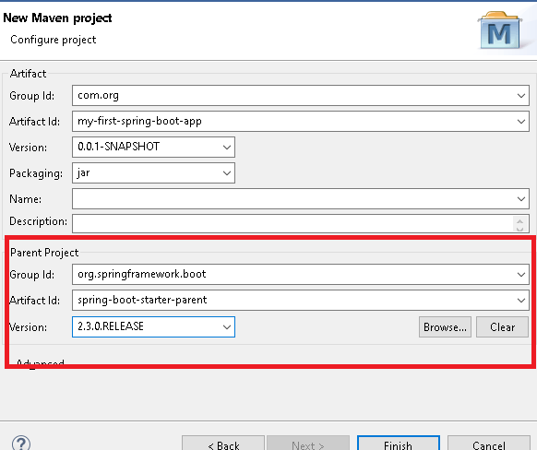

pom.xml

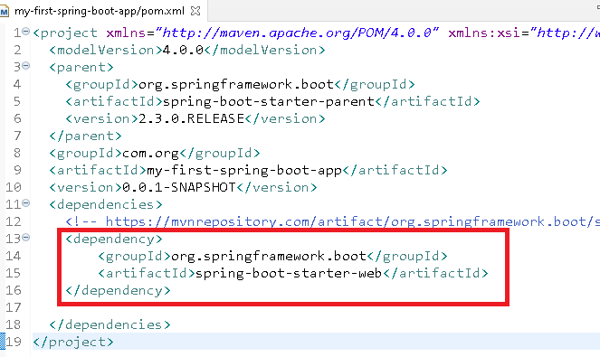

Application.java

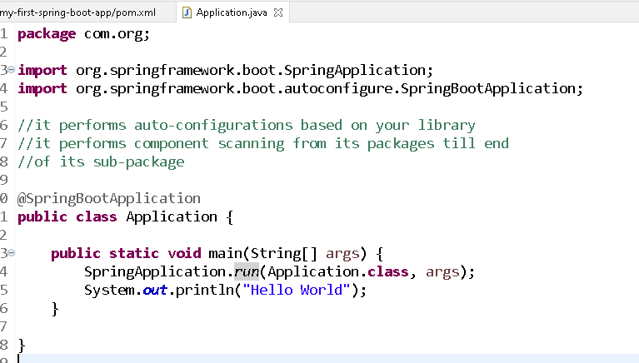

@SpringBootApplication will do auto-configurations like

* stating a tomcat server
* component scanning from its root package
* configuring dispatcher servlet
* reading application.properties & configuring the application

application.properties file should be created inside src/main/resources folder, however you can have yml file instead of properties i.e, application.yml

You can add spring boot devtools to automatically reload your application on server

pom.xml

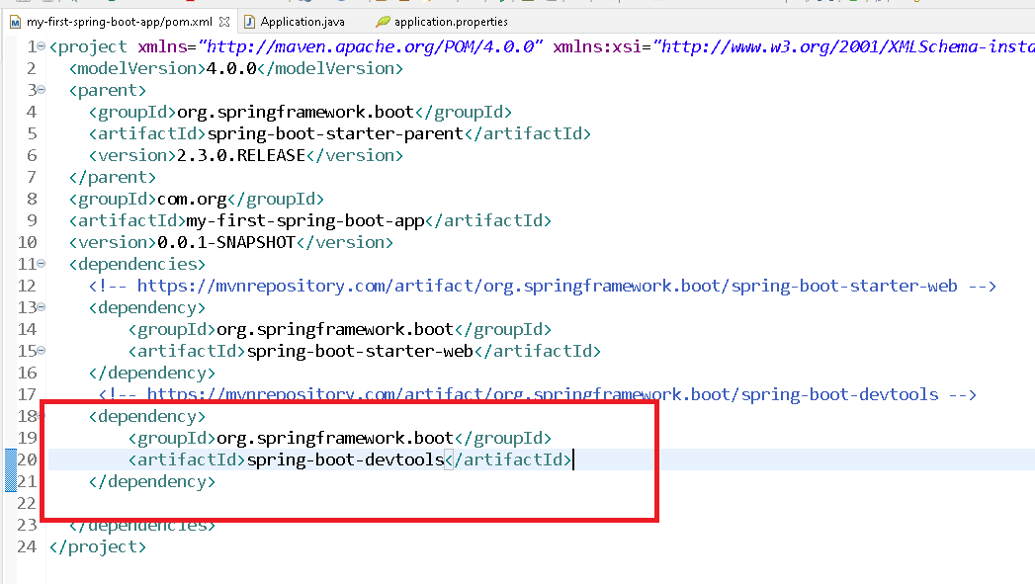

create application.properties inside the src/main/resources

